ADMINISTRATOR TRAINING GUIDE
Estimate Cases and AI Analysis
How an estimate workspace is created, analyzed, costed, reviewed, and prepared for production output
Purpose: Explain the Estimate Cases pages and the background AI process in simple terms, while clearly identifying production outputs that are still being designed.

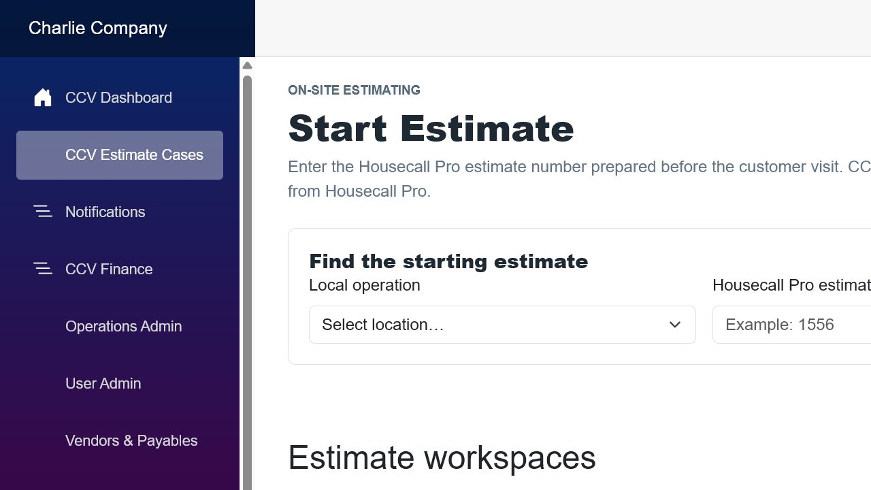
Screen example: start an estimate by retrieving its Housecall Pro estimate, or reopen an existing CCV workspace.

1. What an Estimate Case is
An Estimate Case is CCV’s working copy of an on-site estimate. Housecall Pro remains the source for the starting customer and estimate information. CCV adds project notes, task sections, photographs, AI analysis, costing rules, and an audit history.
Current behavior: The current application can start from a Housecall Pro estimate, maintain project tasks, submit a task for CentCom analysis, match materials to vendor pricing, and calculate a provisional job cost.

Important boundary: The AI result is a recommendation for review. It should not automatically become a supplier order or customer contract.

2. Starting or reopening an Estimate Case
Page area | What the administrator does | What CCV does
Housecall Pro estimate number | Enter the HCP estimate number and retrieve it. | Finds the starting estimate and customer/project information.
Create workspace | Confirm the correct estimate and create the workspace. | Stores a CCV case linked to the HCP estimate.
Existing workspaces | Select a workspace already in progress. | Reopens saved notes, tasks, photographs, analysis revisions, and pricing.
Delete workspace | Use only when the workspace should be permanently removed. | Deletes the CCV workspace after a confirmation prompt; it does not delete HCP’s estimate.

Before creating: Verify the customer and property address. Do not create a second workspace for the same HCP estimate unless there is a deliberate business reason.

3. The Estimate Workspace
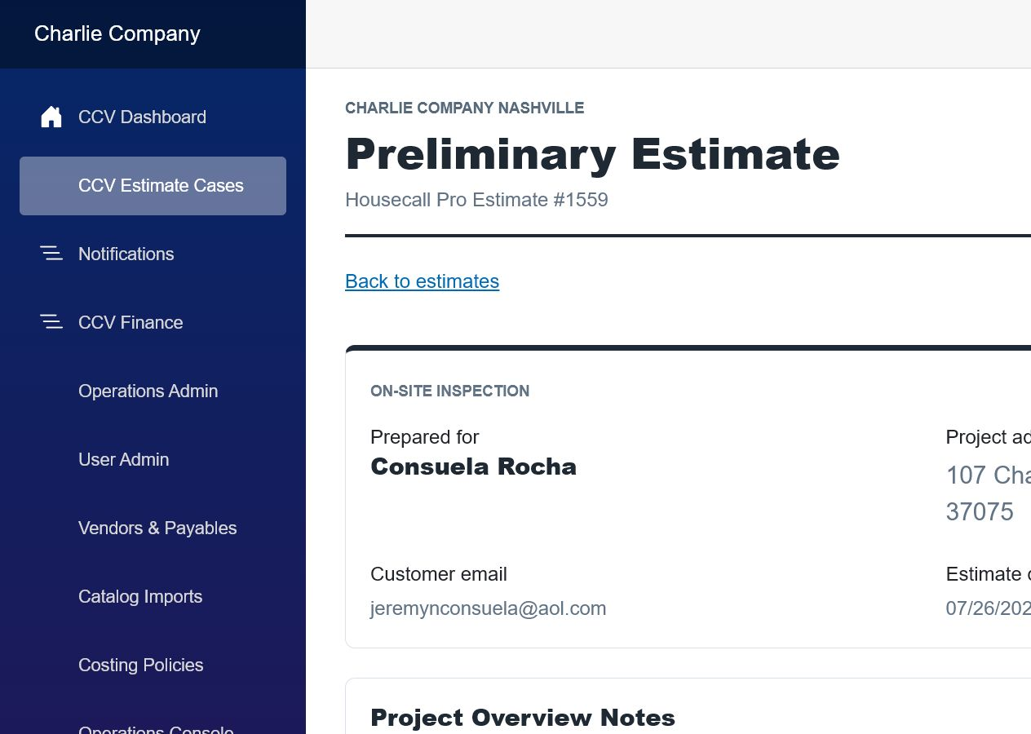
Screen example: the estimate header, customer information, and Project Overview Notes.

Customer and project information
- Customer name, address, contact information, estimate number, and estimate date originate from Housecall Pro.
- The Project Overview Notes describe the entire project, site conditions, goals, and constraints.
- The microphone button can dictate notes when the browser and device permit microphone access.

Project tasks
A case can contain any number of project tasks. Each task represents a distinct piece of work that CentCom can analyze separately.
Task feature | Plain-language purpose | Example
Task number and type | Identifies the work and its order. | Project Task 1 - Deck; Project Task 2 - Roof Structure.
Scope of Work | Estimator’s description of what must be done. | Remove two decks and rebuild with pressure-treated lumber.
Photo template | Requests the views and measurements needed for that task type. | Overall view, length, width, endpoints, stairs, and structural conditions.
Additional photos | Allows useful images beyond the required template. | Access constraints, damage, or unusual framing.
Save Project Task | Stores the current notes and photographs. | Save before leaving the page or starting analysis.
Delete Task | Removes a task after confirmation. | Use when the task was added by mistake.

Good practice: Use one task for each separately costed scope. Clear task boundaries produce clearer material lists, crew assumptions, and margins.

4. CentCom Analysis on the workspace
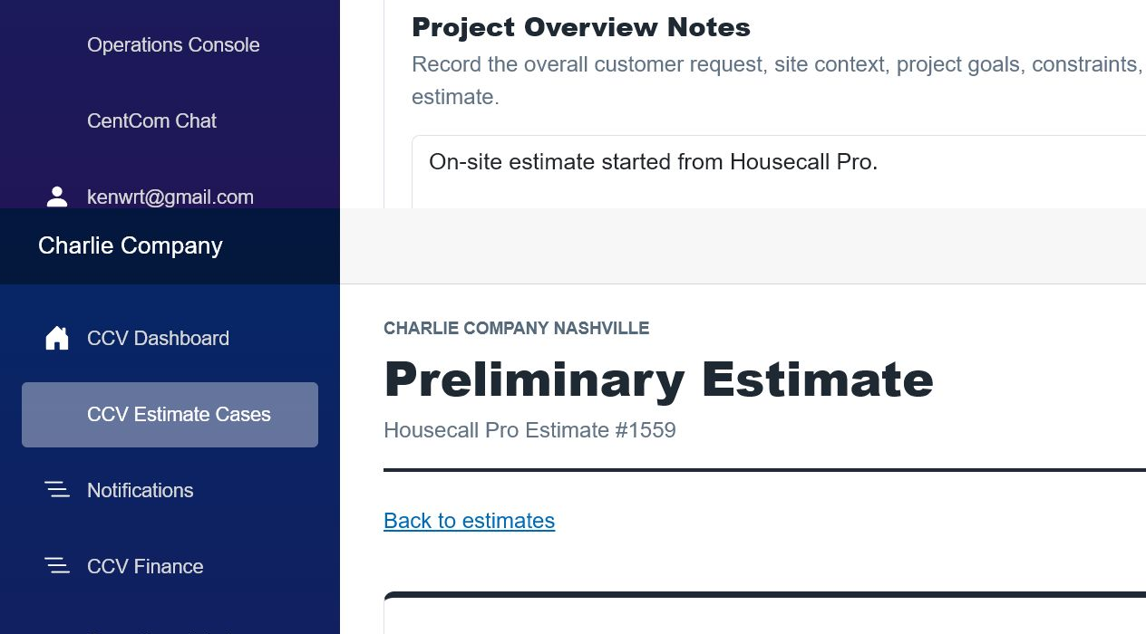
Screen example: the project task and its CentCom analysis area.
- Analyze submits the task’s current saved notes and photographs.
- Queued means the request is waiting for background processing.
- Reanalyze creates a new analysis revision; it does not erase the earlier audit trail.
- Unmatched means CentCom recommended an item that CCV could not safely match to an active vendor catalog item.
- Excluded means a policy intentionally prevented an AI suggestion from entering material cost.
Review required: Unmatched items, missing prices, uncertain quantities, exclusions without recovery, and unexpected task durations must be resolved before approval.

5. Pricing and audit information
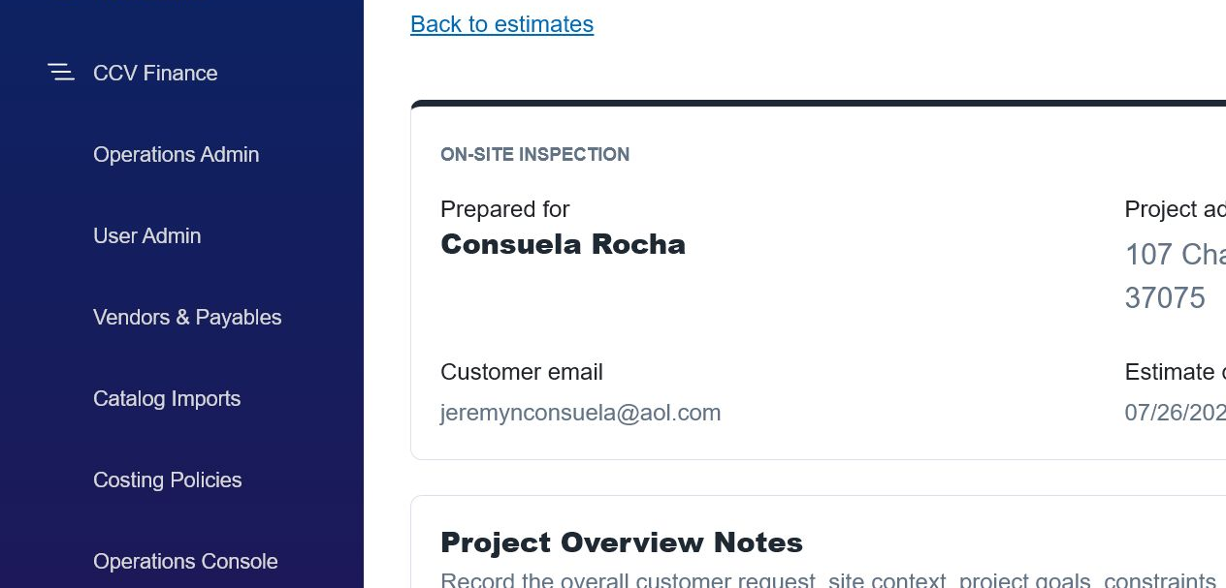
Screen example: job cost summary and provisional pricing information.
The pricing area combines accepted materials with the active costing-policy snapshot. It should explain what was included, which policy revision was used, and how the suggested selling price was calculated.
Cost layer | Typical contents | Source
Materials | Catalog-matched lumber, fasteners, hardware, finishes, and supplies. | CentCom recommendation + vendor catalog + standard supply kits.
Labor | Crew days multiplied by the matching daily crew rate. | Task type/work type crew rate card.
Task/project costs | Disposal, permits, delivery, rental, mobilization, or management. | Additional cost rules.
Overhead | Allocated operating cost and any approved additional overhead. | Active costing policy.
Contingency | Allowance for normal estimating uncertainty. | Policy percentage.
Suggested price | Cost converted to price using the applicable margin. | Task margin rule or policy fallback.

6. What happens in the background when AI analyzes a task
Simple description: CCV takes a frozen copy of the task, asks CentCom for a structured recommendation, checks that recommendation against approved business data, calculates costs, and saves a new auditable revision.

1. Submission
The user saves the task and clicks Analyze or Reanalyze.

2. Input snapshot
CCV records the task type, work type, notes, photographs, customer/project context, user, time, and revision number.

3. Queue
A background job is created with Queued status so the web page does not need to remain open.

4. Worker claims the job
A background service selects the queued job and marks it Processing. Duplicate workers must not process the same revision.

5. Validation
The worker checks CentCom configuration, usable scope notes, photo references, operation access, and required identifiers.

6. Business context
CCV loads relevant vendor catalog pricing, standard supply kits, crew rates, margin rules, additional costs, overhead policy, and material exclusions.

7. CentCom request
CCV sends a task-specific instruction asking for structured materials, quantities, assumptions, estimated project days, confidence, and warnings.

8. Response validation
CCV verifies the response format and rejects incomplete or unsafe output instead of silently guessing.

9. Material normalization
Descriptions, units, quantities, waste, and categories are normalized for matching.

10. Catalog matching
Each recommended material is matched to an active vendor catalog item. Uncertain matches remain Unmatched for human review.

11. Exclusions and kits
Policy exclusions prevent duplicate or inappropriate suggestions; required standard kits are added automatically.

12. Cost calculation
CCV calculates materials, labor, task/project costs, overhead, contingency, and margin using the applicable policy revision.

13. Save revision
The raw technical response, normalized recommendations, matches, exclusions, assumptions, costs, errors, and timestamps are saved.

14. Finish or fail
The job becomes Completed, Needs Review, or Failed. A failed revision retains a readable reason and can be retried.

7. What should be visible in the operations console
Event | Minimum information | Why it matters
Queued | Time, operation, estimate, task, revision, requesting user. | Shows that the request was accepted.
Processing | Worker/service, model, start time, correlation ID. | Shows where the job is running.
Completed | Duration, material count, matched/unmatched count, cost totals, warnings. | Shows success and review needs.
Needs Review | Missing prices, low confidence, exclusions, or questionable quantities. | Routes work to an administrator.
Failed | Module, readable error, technical details, retry count, next action. | Makes failures diagnosable.

Consolidated logging: When UI and APIs run on different machines, every service should write events using the same estimate ID, task ID, revision, operation, and correlation ID. CCV can then display one chronological timeline.

8. Proposed production outputs - not finalized
Design status: The following outputs are recommended next steps, not a statement that they are fully implemented. Business approval, security decisions, supplier preferences, and legal review are still required.

A. Supplier material list or request for pricing
- Generate one supplier-specific list from approved, catalog-matched items.
- Include estimate/job reference, delivery location, quantities, units, requested delivery date, and special instructions.
- Do not include the customer’s selling price, margin, internal overhead, or unrelated personal information.
- Require an administrator to review and approve the email before it is sent, at least during the initial rollout.
Recommended trigger: Estimate analysis approved and material selections locked - not merely when AI processing completes.

B. Internal cost analysis for dashboards
- Display material, labor, task costs, overhead, contingency, total cost, suggested price, and margin.
- Show the exact analysis and policy revisions used.
- Show unmatched items, missing prices, low-confidence recommendations, and overrides.
- Allow drill-down from group to local operation, estimate, task, and individual cost line.
Audience: Administrators and authorized local operators. Internal costs and margins should never appear on a customer-facing page.

C. Customer-facing polished estimate
- Customer and property information, project overview, task-by-task scope, selections, and pricing.
- Clear inclusions, exclusions, allowances, change-order rules, payment schedule, expiration date, and signature/acceptance.
- Approved photographs or diagrams only when they help explain the work.
- No raw AI response, confidence score, vendor cost, internal labor cost, overhead, or margin.
Legal gate: Customer terms and legal language must be approved by qualified counsel for each operating jurisdiction. AI may assemble approved clauses, but it should not invent legal terms.

Send gate: The customer document should require estimator or manager approval before email delivery. Analysis completion alone should never send it.

9. Recommended notifications
Notification | Primary recipient | Suggested channel | Approval needed?
Analysis queued | Requesting user | In-app status | No
Analysis completed - clean | Requesting user | In-app; optional email | No
Analysis needs review | Estimator + assigned administrator | In-app + email | No
Analysis failed | Administrator/operations console | In-app + email | No
Supplier list ready | Estimator or purchasing approver | In-app | Yes, before supplier email
Supplier email sent | Purchasing + audit log | In-app; copy by policy | Recorded approval
Customer estimate ready | Estimator/manager | In-app + email | Yes, before customer send
Customer estimate sent | Estimator + audit log | In-app; delivery tracking | Recorded approval

Noise control: Use email for action-required or failed events. Routine progress should remain in the application. SMS should be reserved for truly urgent, opt-in events.

10. Decisions still needed before production output
- ☐ Who can approve an AI analysis, supplier request, and customer estimate?
- ☐ Which unmatched-item or confidence thresholds require review?
- ☐ Which suppliers accept email lists, CSV attachments, PDFs, or API orders?
- ☐ Should supplier communication be a price request, purchase order, or delivery request?
- ☐ What cost and margin details can local operators see?
- ☐ Which legal clause library applies to each state and local operation?
- ☐ What customer document numbering, expiration, deposit, and signature rules are required?
- ☐ Which events use in-app notification, email, SMS, or no notification?
- ☐ How long are raw AI responses, photos, approvals, and delivery records retained?
- ☐ What is the rollback process when catalog prices or policy assumptions are wrong?

Administrator test checklist
- ☐ Retrieve the correct Housecall Pro estimate and verify the customer and property.
- ☐ Enter project overview notes and create clearly separated tasks.
- ☐ Save notes and required photographs before analysis.
- ☐ Confirm the analysis progresses from Queued to a final status.
- ☐ Review materials, quantities, days, assumptions, catalog matches, and exclusions.
- ☐ Resolve every unmatched or unpriced item.
- ☐ Verify the correct crew rate, policy revision, overhead, contingency, and margin.
- ☐ Confirm Reanalyze creates a new revision and preserves the earlier audit.
- ☐ Do not send supplier or customer output until the applicable approval workflow exists.
Final principle: AI prepares a recommendation. CCV validates and costs it. An authorized person approves what leaves the company.

